Lab # 02 OBJECT

To Study about basics of:
* Network Topology and its Types

THEORY

Network Topology:

A network topology is a pattern in which nodes(e.g. printer, computer, router or other devices) are connected to a Local Area Network(LAN) or other networks via a links(erg twisted pair, copper wire cable or optical fiber cable).

Main Types of Network Topologies:

The following sections discuss the physical topologies used in networks and other related topics.

- Linear Bus 
- Star    • Ring 
- Mesh 

Lin ear Bus:
.

Bus topology is a network type in where every computer and network device is connected to single cable.

In the bus network topology, every work station is connected to a main cable called the bus. Therefore, in effect, each workstation is directly connected to every other workstation in the network.

Advantages of Linear Bus Topology:

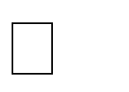




It is cost effective.
Cable required is least compared to other network topology. Used in small networks.
It is easy to understand.
Easy to expand joining two cables together.

Disadvantages of Linear Bus Topology:





Cables fails then whole network fails.
If network traffic is heavy or nodes are more the performance of the network decreases. Cable has a limited length. It is slower than the ring topology.

Star:
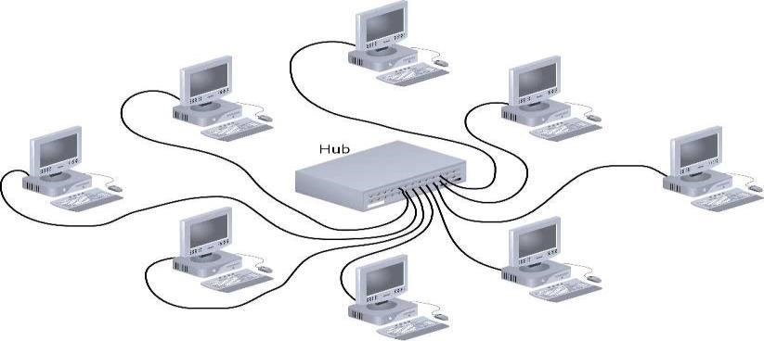

In this type of topology all the computers are connected to a single hub through a cable. This hub is the central node and all others nodes are connected to the central node.

Advantages of Star Topology:

- Fast performance with few nodes and low network traffic. 
- Hub can be upgraded easily. 
- Easy to troubleshoot. 
- Easy to setup and modify. 
- Only that node is affected which has failed rest of the nodes can work smoothly. 

Disadvantages of Star Topology:

- Cost of installation is high. 
- Expensive to use. 

Ring:

It is called ring topology because it forms a ring as each computer is connected to another computer, with the last one connected to the first. Exactly two neighbors for each cable device.

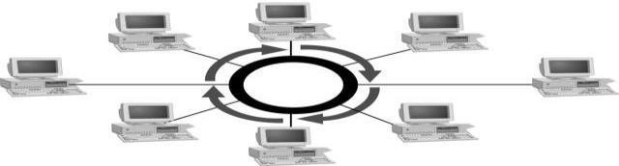

Advantages of Ring Topology:

- Transmitting network is not affected by high traffic or by adding more nodes, as only the nodes having tokens can transmit data. 
- Cheap to install and expand. 

Disadvantages of Ring Topology:




Troubleshooting is difficult in ring topology.
Adding or deleting the computers disturbs the network activity. Failure of one computer disturbs the whole network.

Mesh:

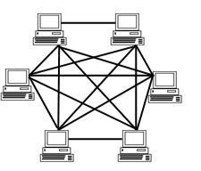

A network setup where each computer and network device is interconnected with one another.

There are two types of mesh topology network:

- Fully mesh network 
- Partially mesh network 

Advantages of Mesh Topology:

- each node is connected to several others; when a node fails its neighbors find other routes 
- capacity can be added simply by adding nodes 

Disadvantages of Mesh Topology:

- There are high chances of redundancy in many of the network connections. 
- Expensive. 
- Maintenance is difficult. 

Considerations when choosing a Topology:

Money: A linear bus network may be the least expensive way to install a network; you do not have to purchase concentrators.

Length of cable needed: The linear bus network uses shorter lengths of cable.

Future growth: With a star topology, expanding a network is easily done by adding another concentrator.

Cable type: The most common cable in schools is unshielded twisted pair, which is most often used with star topologies.

LAB TASK:

- What is difference between partial and full mesh topology?

__________________________________________________________________
__________________________________________________________________
__________________________________________________________________
__________________________________________________________________
__________________________________________________________________

- Design Bus and Star Topology environment using Packet Tracer?

